# Problem 1 - Hogwarts

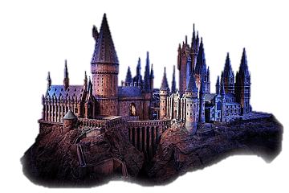

*Welcome, wizard. We have been waiting for you here, in Hogwarts. Get ready to learn a lot of new potions and spells to fight The one who shall not be named. Your first class is Spellcasting.*

First, you will receive **a spell that needs to be deciphered.** Next, you will be receiving **commands** split by a single space until you get the "**Abracadabra**" command. There are **5 possible commands:**

* **"Abjuration"**
  + **Replace** all letters with **upper case** and **print** the result.
* **"Necromancy"**
  + **Replace** all letters with **lower case** and **print** the result.
* **"Illusion {index} {letter}"**
  + **Replace** the letter at the index with the given one and print **"Done!"**
  + If the index is **invalid,** print: **"The spell was too weak."**
* **"Divination {first substring} {second substring}"**
  + **Replace** the **first substring (all matches)** with the **second** and **print the result**.
  + If the substring **does not exist**, **skip** the command.
* **"Alteration {substring}"**
  + **Remove** the **substring from the string** and **print the result**.
  + If the substring **does not exist**, **skip** the command.

If the input command is **not** in the list, print **"The spell did not work!".**

## Input / Constraints

* On the **1st line,** you are going to receive the **string**.
* On the next **lines**, until you receive **"Abracadabra"**, you will be receiving commands.
* All commands are **case-sensitive**.

## Output

* **Print** the **output** of the **commands** in the **format described above**.

## Examples

|  |  |
| --- | --- |
| **Input** | **Output** |
| A7ci0  Illusion 1 c  Illusion 4 o  Abjuration  Abracadabra | Done!  Done!  ACCIO |
| TR1GG3R  Necromancy  Illusion 8 m  Illusion 9 n  Abracadabra | tr1gg3r  The spell was too weak.  The spell was too weak. |
| SwordMaster  Target Target Target  Abjuration  Necromancy  Alteration master  Abracadabra | The spell did not work!  SWORDMASTER  swordmaster  sword |

## JS Examples

|  |  |
| --- | --- |
| **Input** | **Output** |
| (["A7ci0",  "Illusion 1 c",  "Illusion 4 o",  "Abjuration",  "Abracadabra"]) | Done!  Done!  ACCIO |
| (["TR1GG3R",  "Necromancy",  "Illusion 8 m",  "Illusion 9 n",  "Abracadabra"]) | tr1gg3r  The spell was too weak.  The spell was too weak. |
| (["SwordMaster",  "Target Target Target",  "Abjuration",  "Necromancy",  "Alteration master",  "Abracadabra"]) | The spell did not work!  SWORDMASTER  swordmaster  sword |